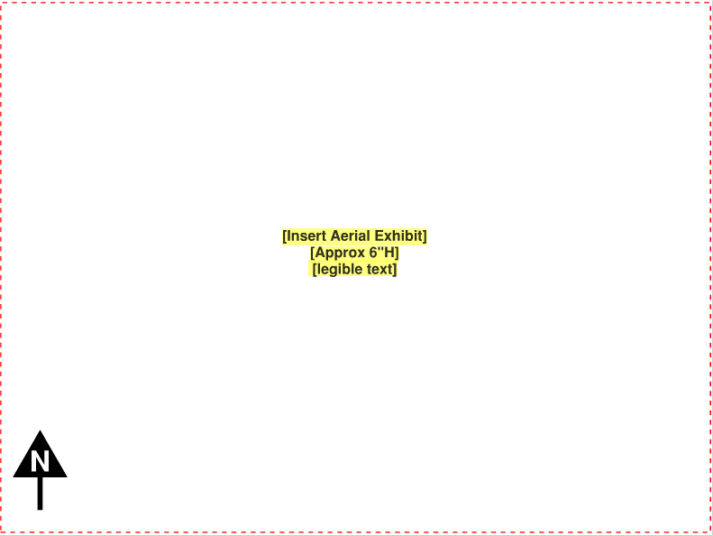
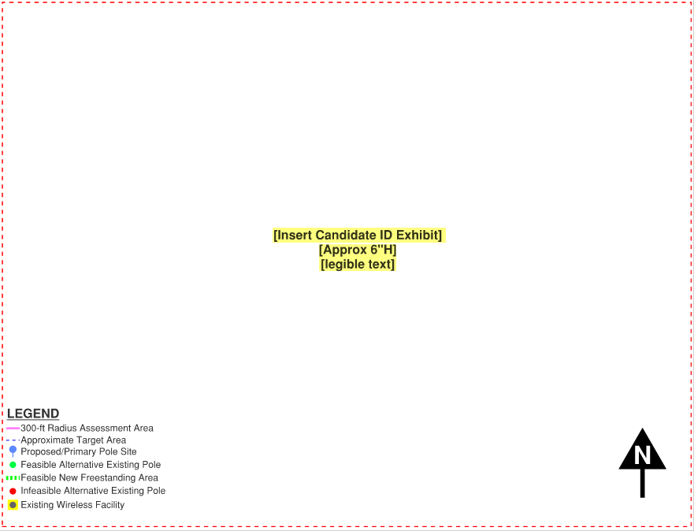

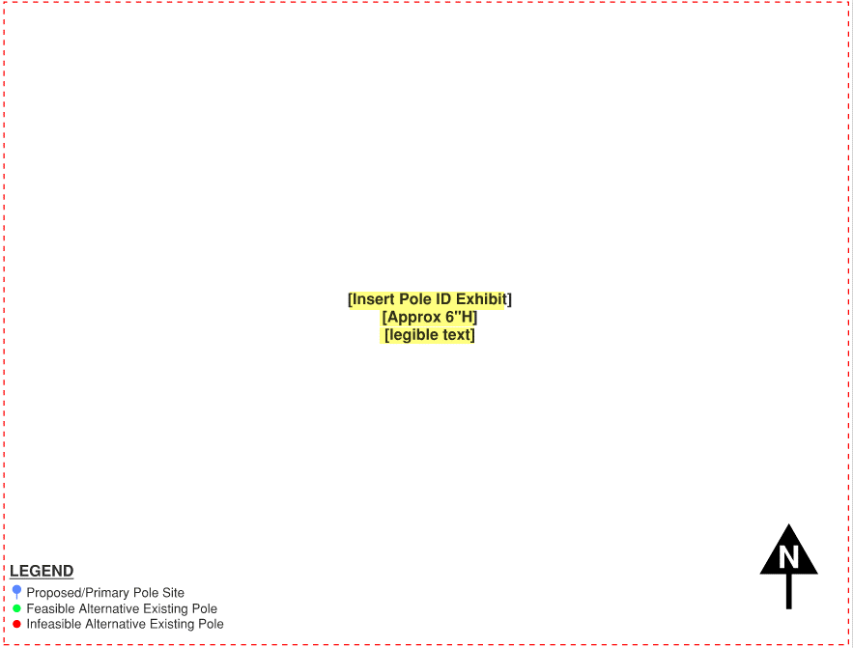

TECHNICALLY FEASIBLE LOCATIONS
Site | Pole ID | Pole Material  and Type | Nearest Address | Adjacent Zoning | Street Class | Nearest Res/  Daycare/School  (Feet) | Existing SWF within 300’ | Location Preference Level | Preferred Site Location | Restricted Site Location

TECHNICALLY INFEASIBLE LOCATIONS
Site | Pole ID | Pole Material  and Type | Nearest Address | Infeasibility Justification

